**Webdriver sample script:**

In test plan-right click-add-thread –thread group.

Add the thread Group ànd add the config element select the element jp@gc chromeDriver Config

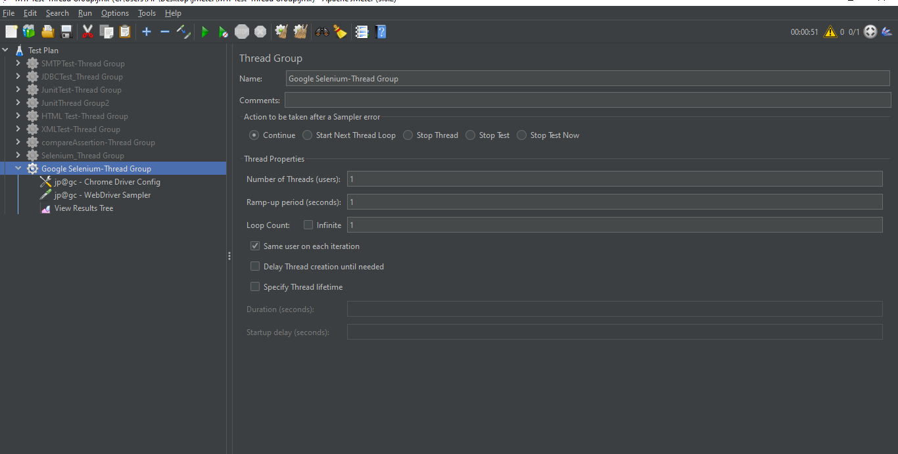

For Jmeter to create a session with your chrome browser, we have to download chromedriver.exe,This has to be downloaded from selenium downloads website.

We have to give path of chromedriver.exe in ChromeDriver config

Download that version of chromedriver which is same as that of your chrome browser version, Extract the contents fot he zip file.

Copy the path of chromedriver folder and give it in Jmeter. add the file name also at the end as chromedriver.exe

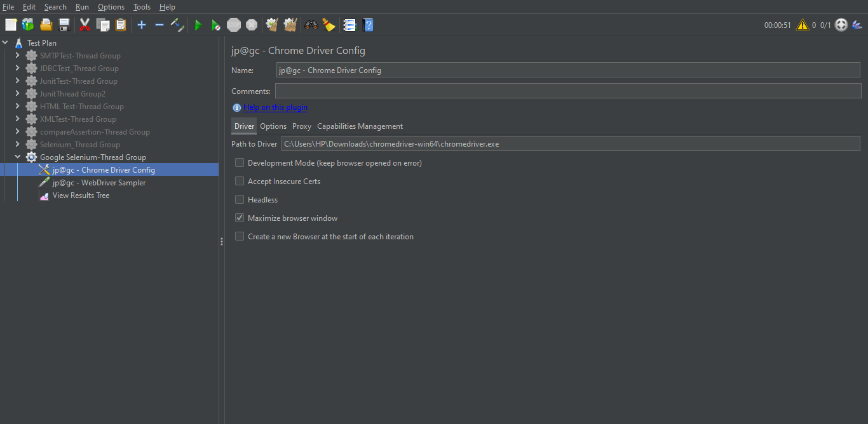

The below is for script writing to execute jp@gcWebdriver sampler.

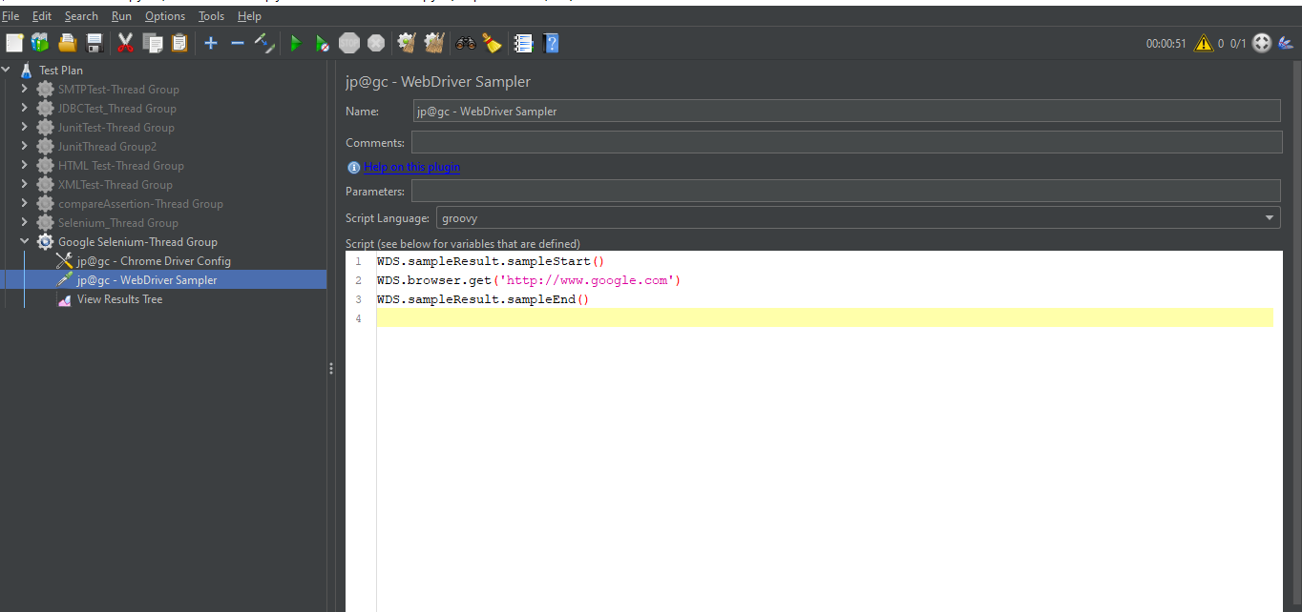

The above script will run and open the chrome browser and below is the test result.

